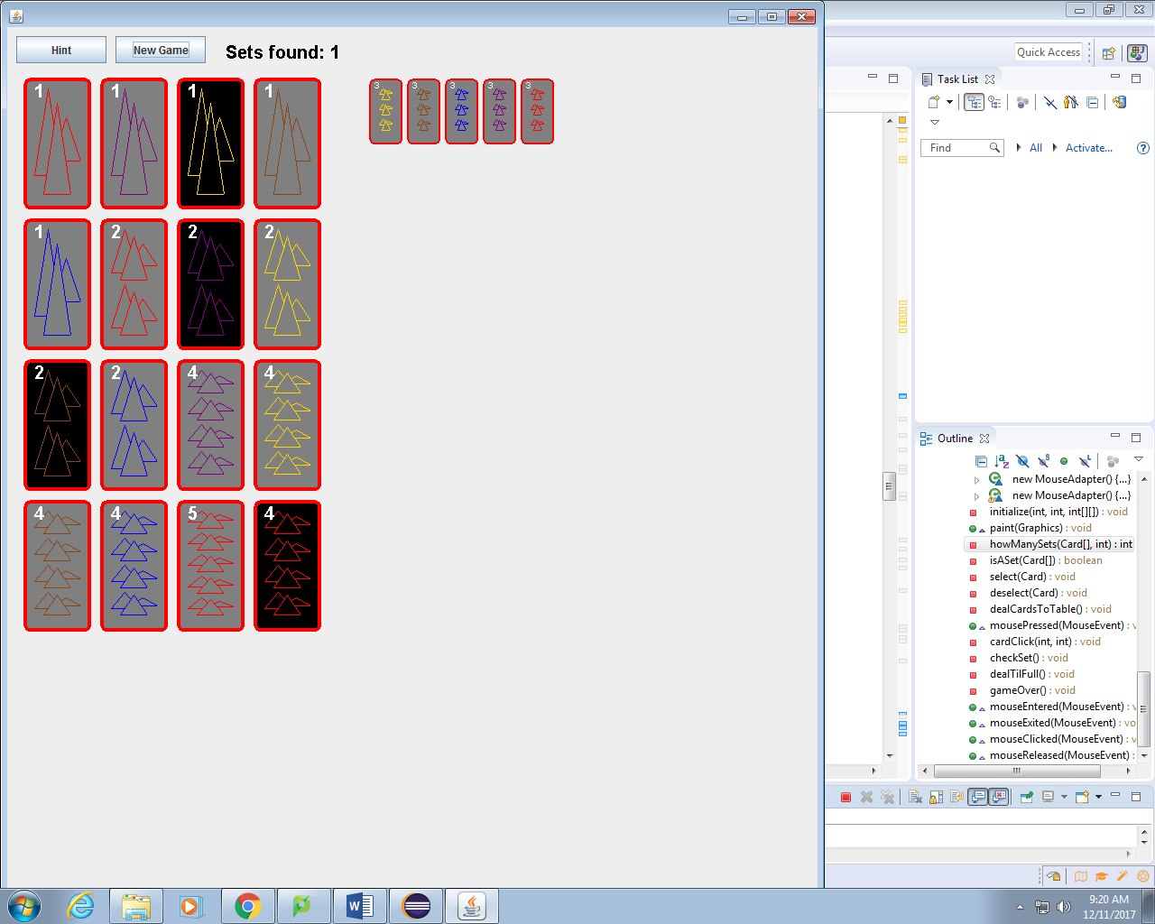

**SET UNBOUNDED**

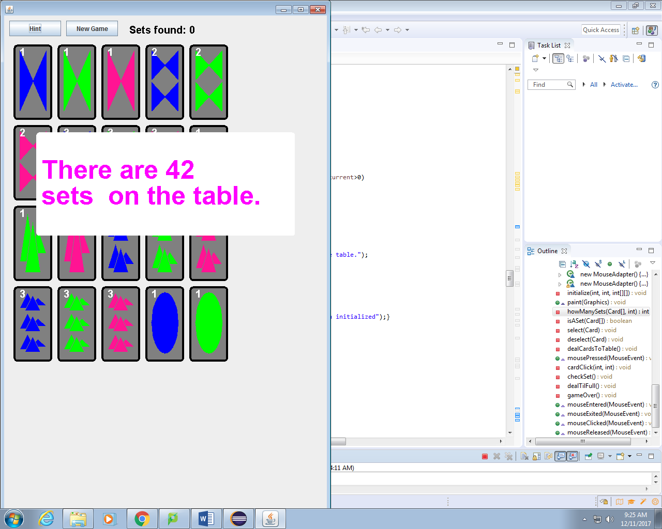

Hann Lerum and Frank Stumbo

December 11, 2017



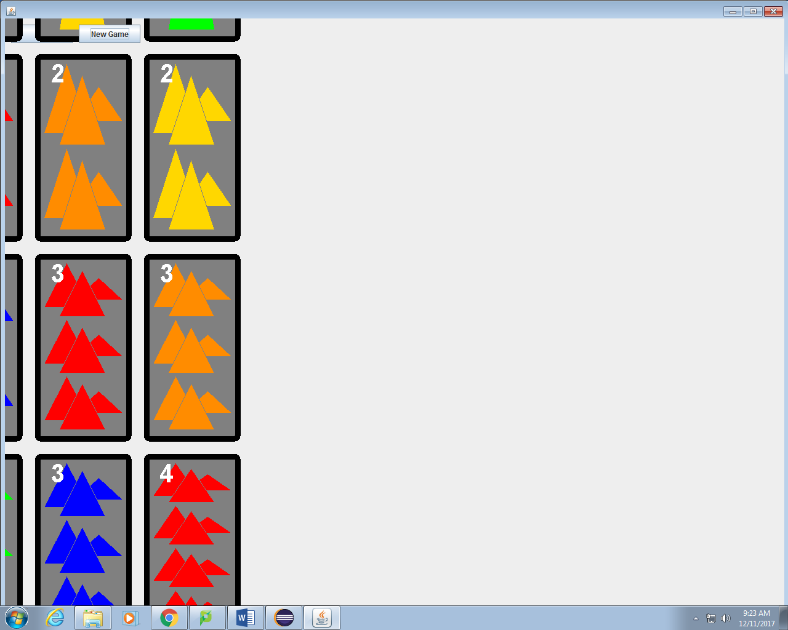



# Introduction

Set Unbounded takes the original pattern recognition card game and unshackles it from all the constraints of paper cards. Pick the shapes, colors, size of a set to make each game your own as you tax your brain to the limit looking for a green bowtie or two painted mountains to complete a set.

Contents

Introduction 2

Accomplishments 2

Features 2

Choose Your Adventure 3

The Images 3

Checking the Sets 3

Extra Code 4

GANTT Chart 4

SCRUM Diagram 4

UML Diagram 5

Development 5

Testing 5

Conclusion 5

Appendix A 6

# Accomplishments

Set Unbounded was made with love, hard work, and much debugging. The code is malleable and could easily be manipulated to allow for extra shapes, more variables, or whatever you could want to add. The production of the code followed a professional and client friendly process with snapshots available at every step and utilized the SCRUM process while staying up to date on a detailed GANTT chart. The code was also written utilizing every available resource with independent research being done online as well as consultations with colleagues and professors to expedite the finished product.

# Features

## Choose Your Adventure

The user-friendly start menu allows the player to personalize every game even setting the level of the challenge. The start menu can boast over fifteen colors and 6 shapes to choose from as well as a pre-programmed default deck if the player wants a quick start.

## The Images

All of the graphics were coded using vectors and the draw functions in java allowing them to scale to the size of the screen. In particular the code for the mountain image shows overlapping shapes that merge seamlessly and are coded to work with multiple fills including empty and cross lined.

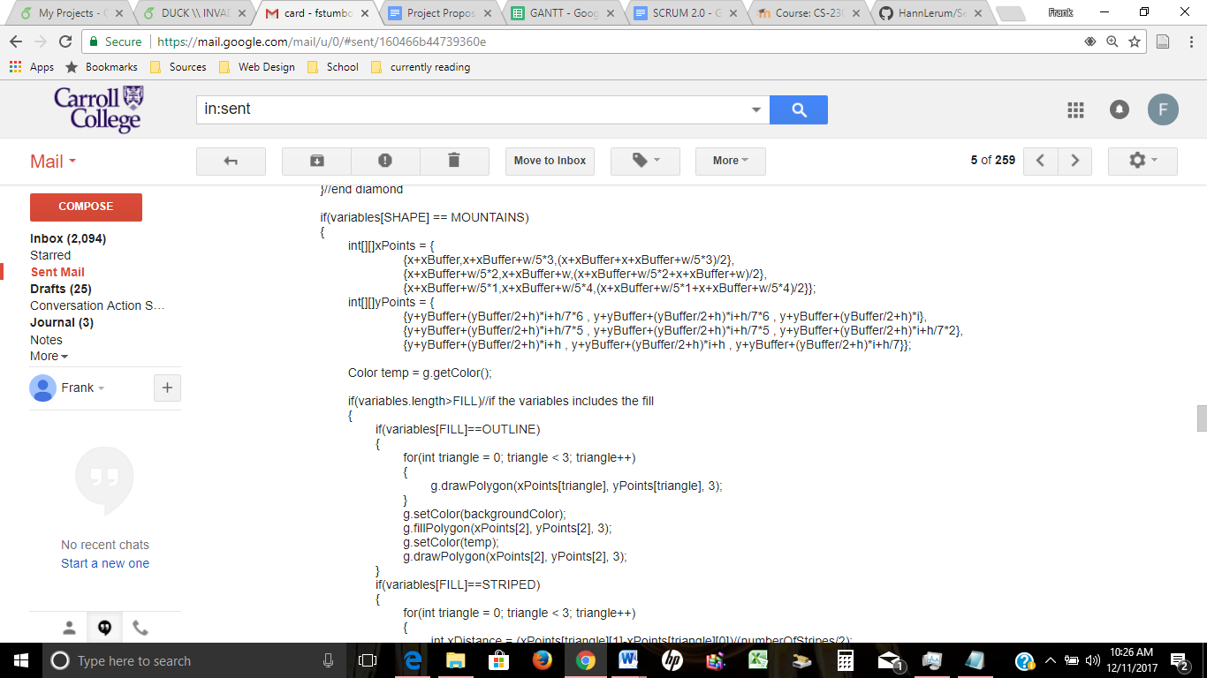

## Checking the Sets

The code also uses an expandable algorithm to check the cards on the table. The code will work on any number of cards on the table as well as any set size or number of variables. It checks to make sure that there are sets on the table too meaning that the user is never looking for a non-existent set.

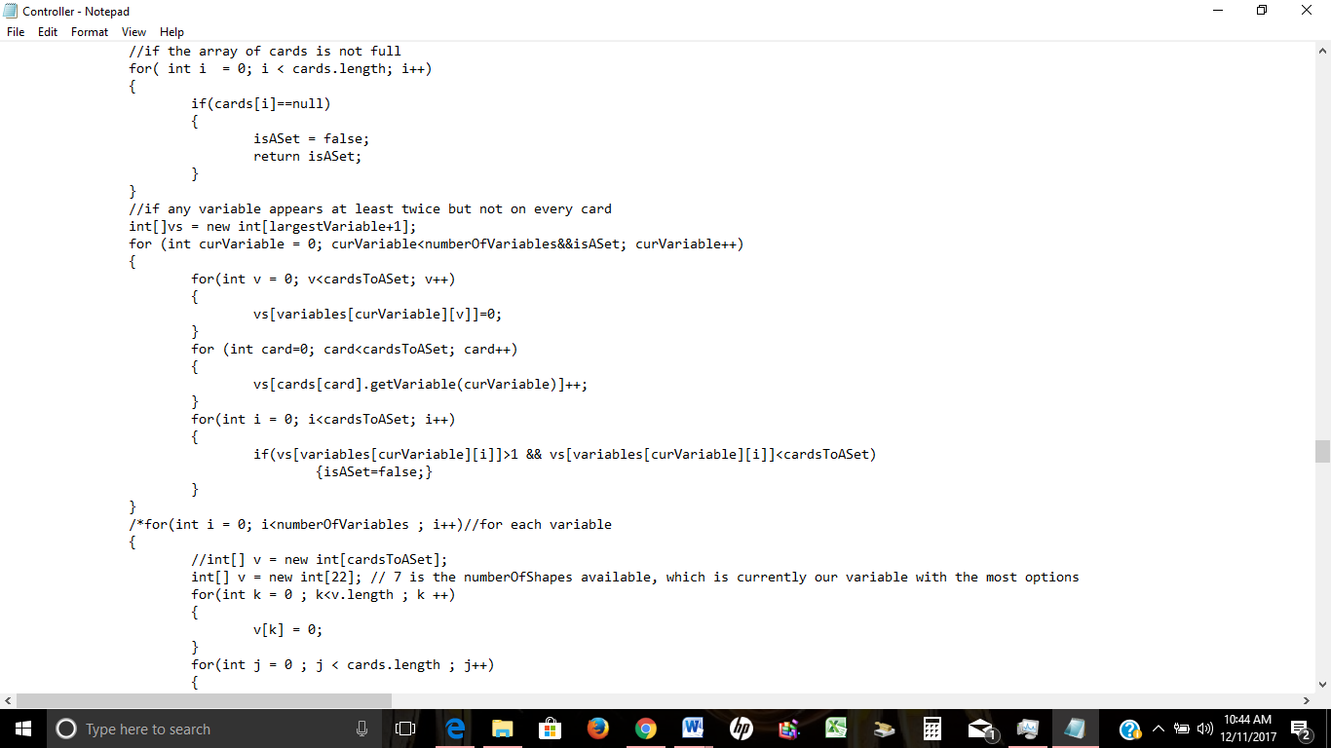

# GANTT Chart

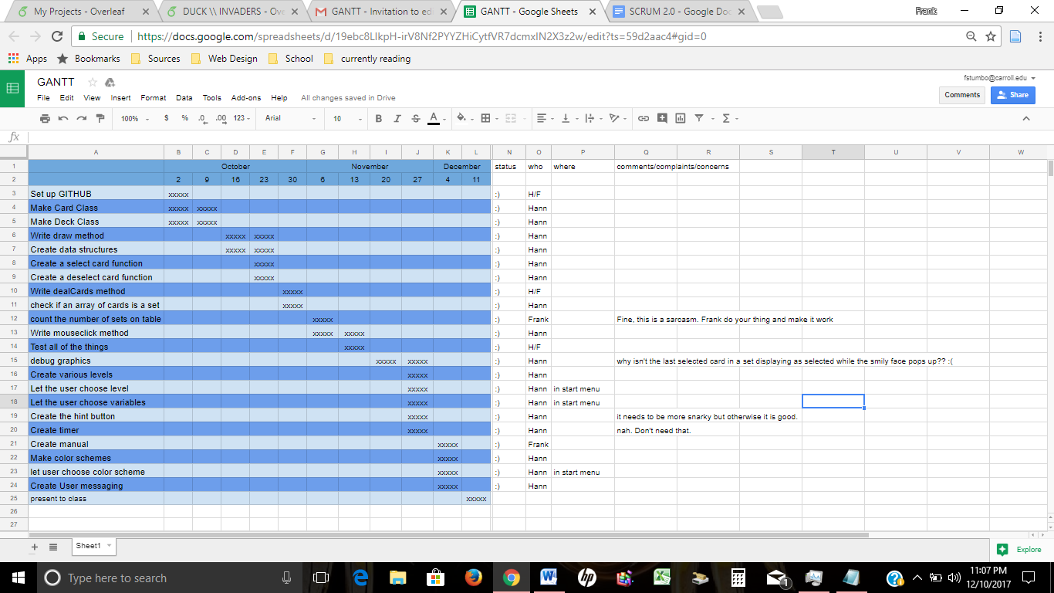

# 

# SCRUM Diagram

**Vision**

We will make a game of Set and it shall be great.

**Project backlog**

Make a single card and display it on the screen

Make it so that you can click that card

Make it so that cards can be deselected by clicking again

Put several cards on the screen

Be able to select three cards

Have the program tell what is a set and what’s not

Remove sets from screen

Establish points system

Make the entire deck of cards

Make the cards shuffle before playing

Make the cards pretty

Create hint button

When clicked, the hint button will give a hint.

Have the program count sets on the table

Create various levels

Let the user choose levels.

Test all the things

Let the user choose color scheme

Create user messaging

**Sprint Backlog**

GITHUB

Make a card; display it on the screen

Be able to click the card

# UML Diagram

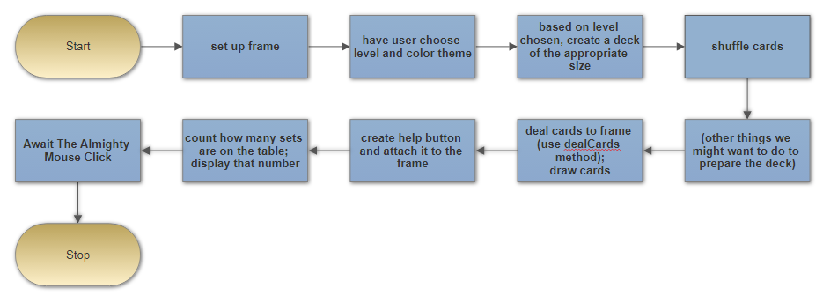

# Development

This was created as a class project for Professor Steven Harper’s Software Engineering 230 class.

# Testing

The code was continuously tested and debugged during and after creation process. Several bugs were worked out including some of the graphics that chose not to play nice. The isASet method that checks the selected cards was streamlined too allowing the code to run seamlessly.

# Conclusion

The project was a great opportunity to both learn new and exciting tricks in coding and practice using project management tools with a partner. We both tracked our changes in GitHub and several times worked together to integrate code we had written independently. The finished product is something we are both proud of and is a game that is fun and exciting.

## Appendix A

